**Title** Tag

**Tag line** “You’re it.”

**Team Members** Chris Prosser, David Goehring, Matt Goehring

**Genre** Arcade /Platforming

**Setting** All places at all times

**Plays like** Super Smash Bros meets Tag

*Popular Game A Popular Game B or twist*

**Summary of rules and scoring**

Each player controls a sphere, beginning the game at a distinct spawn location on the map. One of the players is designated as “it” (the tagger) and is visually distinct (likely by color). This player moves around the map trying to collide with (“tag”) other players who in turn try to remain untagged for as long as possible. A player tagged by the tagger becomes the new tagger. Time spent as the tagger is constantly tallied, and at the end of a designated time period the player who has spent the least amount of time as “it” is the winner. Supports two players.

**Mechanics**

1. Left/Right movement 3. Falling through platforms

2. Jumping 4. Locked side camera

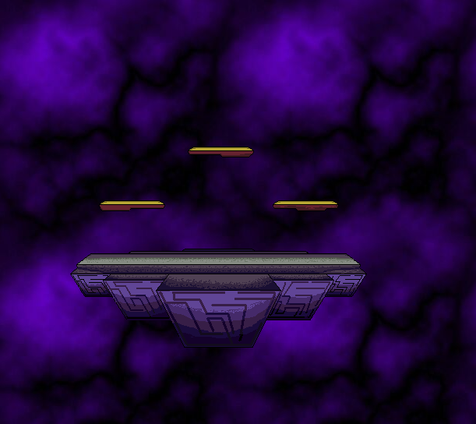 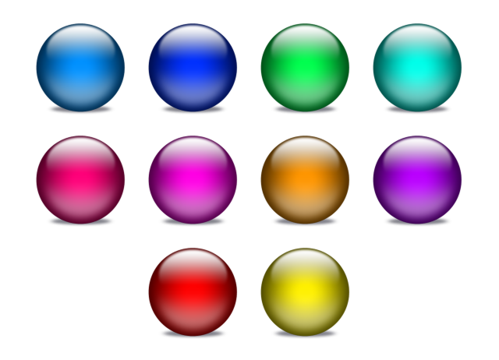

**Reference** **Art**

**Related Games**

1. Super Smash Bros Brawl Nintendo Fighting/Platformer 2008

*Title Publisher or Developer Genre/Platform Year*

Many of Tag’s core mechanics will be similar to Smash Bros, namely movement and jumping onto platforms, but without the complexity of attacking, shields, etc. The design of our stage will also be very similar, but featuring a simple locked camera.

2. LittleBigPlanet Media Molecule/Sony Platformer 2008

*Title Publisher or Developer Genre/Platform Year*

The camera and physics in Tag will be similar to LittleBigPlanet, though not as complex. The perspective will be side-scrolling with no ability for the user to control the camera. The physics will likely be somewhat floaty and not necessarily wholly realistic.

3. Sonic Platformer 2008

*Title Publisher or Developer Genre/Platform Year*

**Storyboards (add additional sheets as needed)**



P1 – 16 s

P2 – 5 s

